Ice Cream Manager [ICM]

Use Case Specification Document

Use Case ID: UC03

Modify Route

Version No. v0.3

Project Document Revision History

|  |  |  |  |
| --- | --- | --- | --- |
| Version | Date | Revision Author | Description of Revision |
| 0.1 | 2016-2-20 | Rodney Lewis | Initial content generation. |
| 0.2 | 2016-3-1 | Rodney Lewis | Added sections 2.0, 3.0, 4.0, 5.0, 7.0, 8.0, 9.0 |
| 0.3 | 2016-3-5 | Rodney Lewis | Added section 1.0, 6.0. Added section 7.0 details. Updated TOC |

Table of Contents

1.0 Introduction 4

2.0 Use Case Information 4

2.1 Actors 4

2.2 Use Case Interaction 4

3.0 Trigger 4

5.0 Post-condition(s) 5

5.1 Displayed list of routes 5

5.2 Displayed truck assigned to route 5

5.3 Displayed the composition of a route 5

6.0 Use Case Activity Diagram 5

6.1 Display route composition/assigned truck 5

6.2 Display truck and route composition 6

7.0 Main/Basic Flow(s) of Events 7

7.1 Display route information 7

7.2 Editing route 7

8.0 Alternate/Exception Flow of Events 7

8.1 Display route information 7

8.2 Editing route 7

From last decision can proceed to edit route. 7

9.0 Assumptions/Business Rules including Non-Functional Requirements 7

10.0 Use Case Specification Review and Signoff 8

# Introduction

Will allow user to view already created routes and the trucks assigned to them. Can view the route the order of zones in that route. Each route can have a preset applied to them to give them a particular inventory. User can modify routes by setting new zones or assigning a new truck to that route.

# 2.0 Use Case Information

## 2.1 Actors

|  |  |  |
| --- | --- | --- |
| Actor Name | Role | Description |
| Manager | Main | Person responsible for the management of trucks and ice cream distribution |

## 2.2 Use Case Interaction

* Predecessor
  + Process batch files
* Successors
  + Modify inventory
  + View sales
  + Modify route
  + Modify truck
  + Modify item
  + Modify driver
  + Modify settings
  + Modify voting
  + Modify presets
  + View fuel usage

# 3.0 Trigger

User choosing to modify and view routes

**4.0 Pre-condition(s)**

**4.1** Process batch files must have been completed previously

# 5.0 Post-condition(s)

## 5.1 Displayed list of routes

## 5.2 Displayed truck assigned to route

## 5.3 Displayed the composition of a route

# 6.0 Use Case Activity Diagram

## 6.1 Display route composition/assigned truck

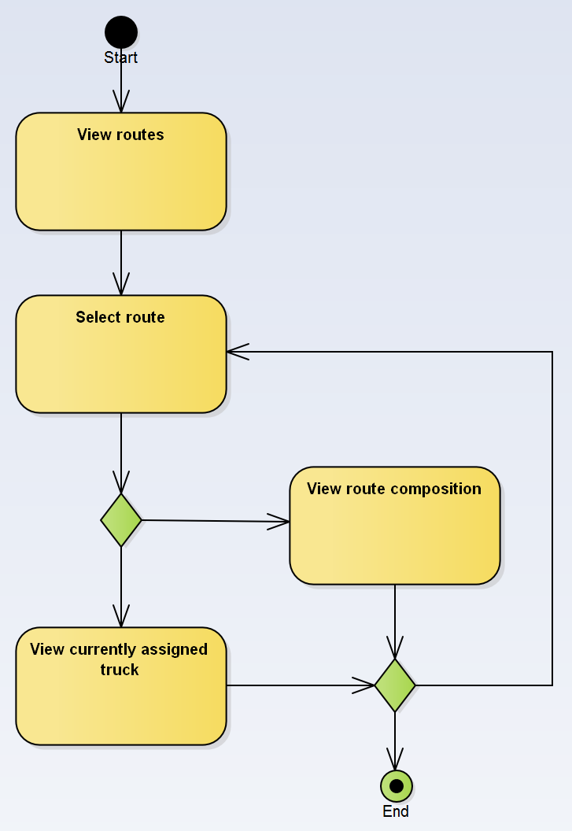

## 6.2 Display truck and route composition

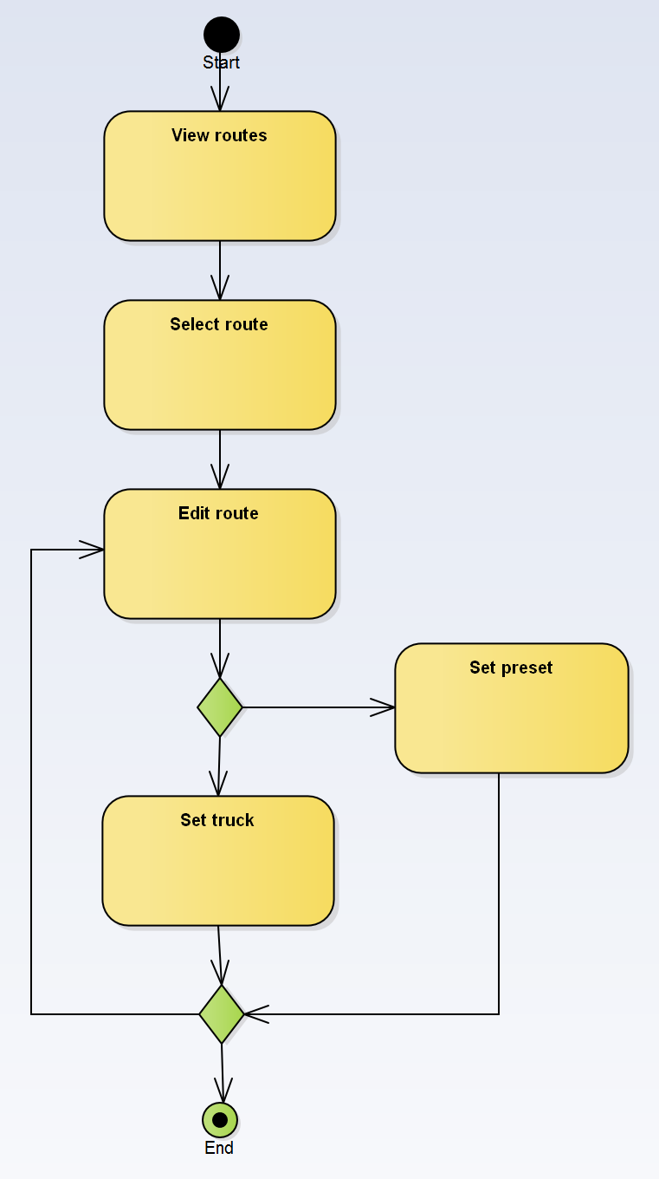

# 7.0 Main/Basic Flow(s) of Events

## 7.1 Display route information

1. View routes: User views list of existing routes
2. Select route: Selecting a single route from list
3. View
   1. Assigned truck OR
   2. Route composition

## 7.2 Editing route

1. View routes: User views list of existing routes
2. Select route: Selecting a single route from list
3. Edit route: Change selected route
   1. Set Preset OR
   2. Assign Truck

# 8.0 Alternate/Exception Flow of Events

## 8.1 Display route information

From last decision can proceed to edit route.

## 8.2 Editing route

## From last decision can proceed to edit route.

# 9.0 Assumptions/Business Rules including Non-Functional Requirements

None

# 10.0 Use Case Specification Review and Signoff

Review and Signoff of the Use Case Specification

|  |  |  |  |
| --- | --- | --- | --- |
| Name | Project Team Role | Signature | Date |
| Camille Williams | Project Manager |  |  |
| Marc King | Team Lead |  |  |
|  |  |  |  |